BeagleBone Green WIreless

<http://wiki.seeed.cc/BeagleBone_Green_Wireless/>

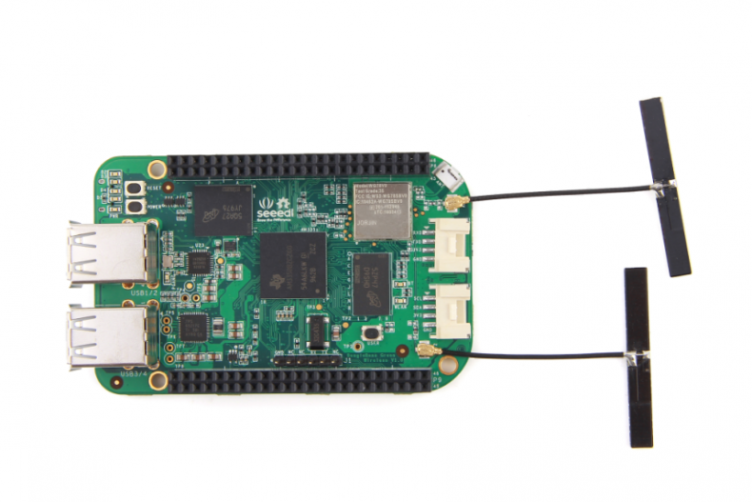

## **Features**

* **Fully Compatiable with BeagleBone Black**
* **Processor: AM335x 1GHz ARM® Cortex-A8**
  + 512MB DDR3 RAM
  + 4GB 8-bit eMMC on-board flash storage
  + 3D graphics accelerator
  + NEON floating-point accelerator
  + 2x PRU 32-bit microcontrollers
* **Connectivity**
  + USB client for power & communications
  + USB host with 4-port hub
  + WiFi 802.11 b/g/n 2.4GHz
  + Bluetooth 4.1 with BLE
  + 2x 46 pin headers
  + 2x Grove connectors (I2C and UART)
* **Software Compatibility**
  + Debian
  + Android
  + Ubuntu
  + Cloud9 IDE on Node.js w/ BoneScript library
  + plus much more

## **Specification**

| **Item** | **Value** |
| --- | --- |
| Processor | AM335x 1GHz ARMR Cortex-A8 |
| RAM | 512MB DDR3 |
| on-board Flash Storage | 4GB eMMC |
| CPU Supports | NEON floating-point & 3D graphics accelerator |
| Micro USB Supports | powering & communications |
| USB | USB2.0 Host *4 |
| Grove Connectors | 2 (One I2C and One UART) |
| GPIO | 2 x 46 pin headers |
| Ethernet | Wi-Fi 802.11b/g/n 2.4GHz and Bluetooth 4.1 LE |
| Operating Temperature | 0 ~ 75 |

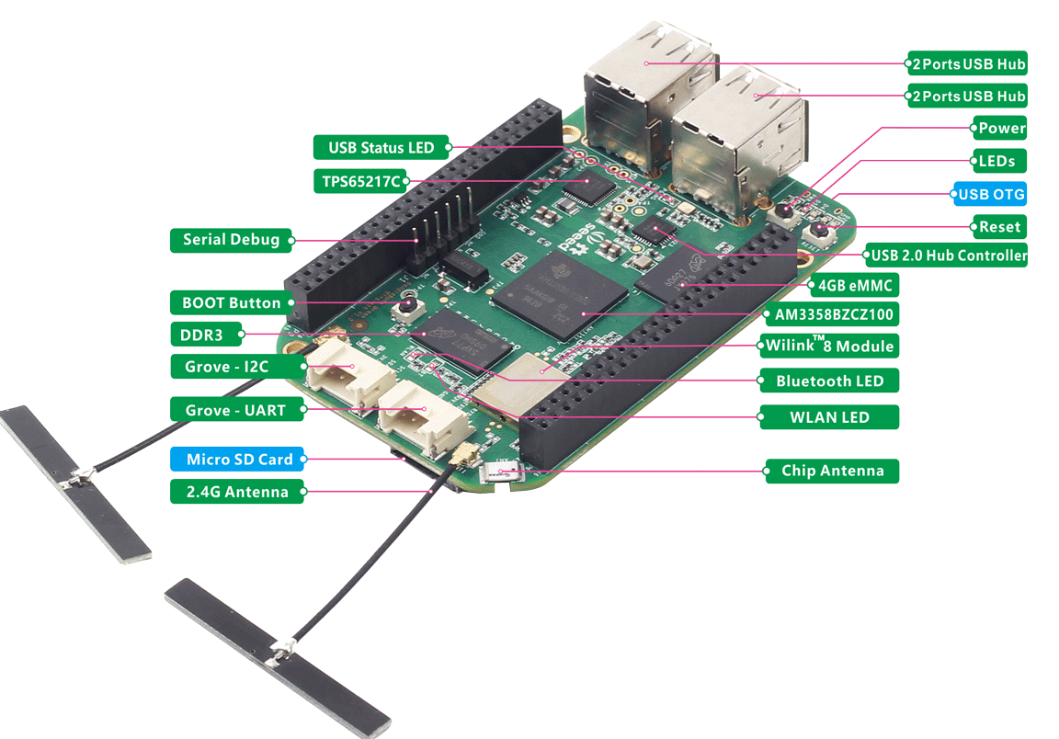

### **Pin map**

Each digital I/O pin has 8 different modes that can be selected, including GPIO.

#### **65 Possible Digital I/Os**

**Note**

In GPIO mode, each digital I/O can produce interrupts.

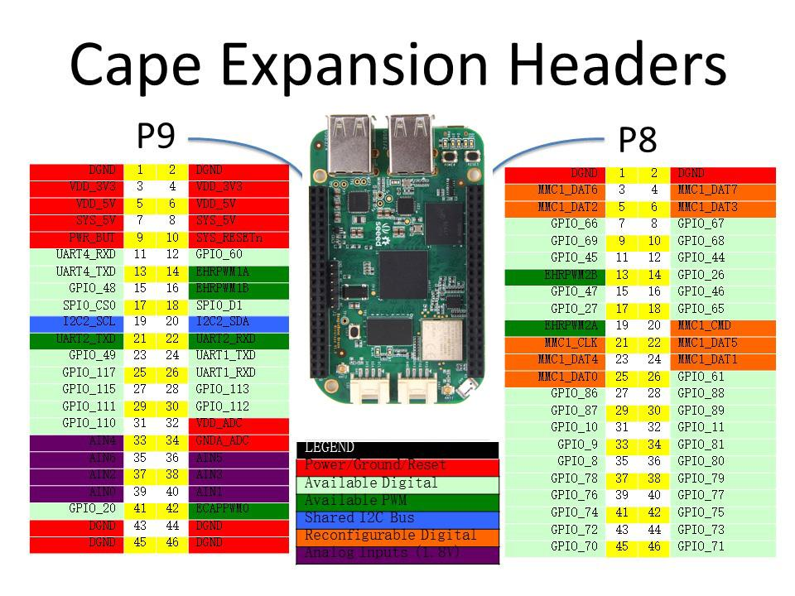

#### **PWMs and Timers**

**Note**

Up to 8 digital I/O pins can be configured with pulse-width modulators (PWM) to produce signals to control motors or create pseudo analog voltage levels, without taking up any extra CPU cycles.

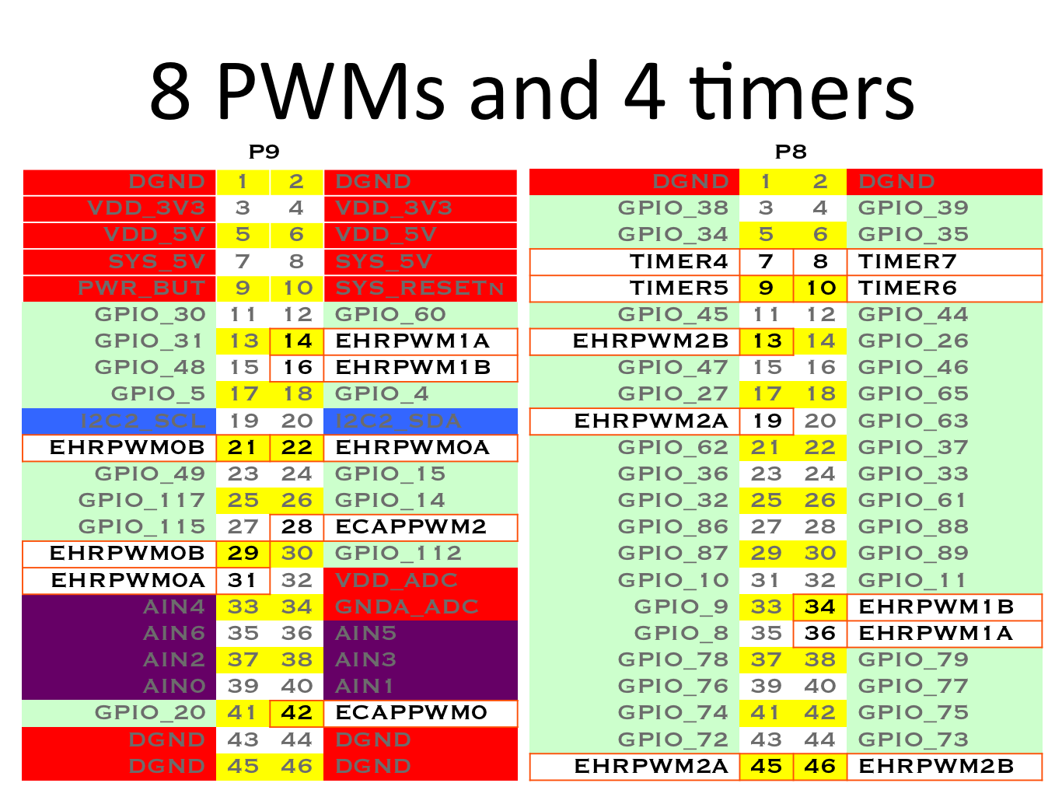

#### **Analog Inputs**

**Note**

Make sure you don’t input more than 1.8V to the analog input pins. This is a single 12-bit analog-to-digital converter with 8 channels, 7 of which are made available on the headers.

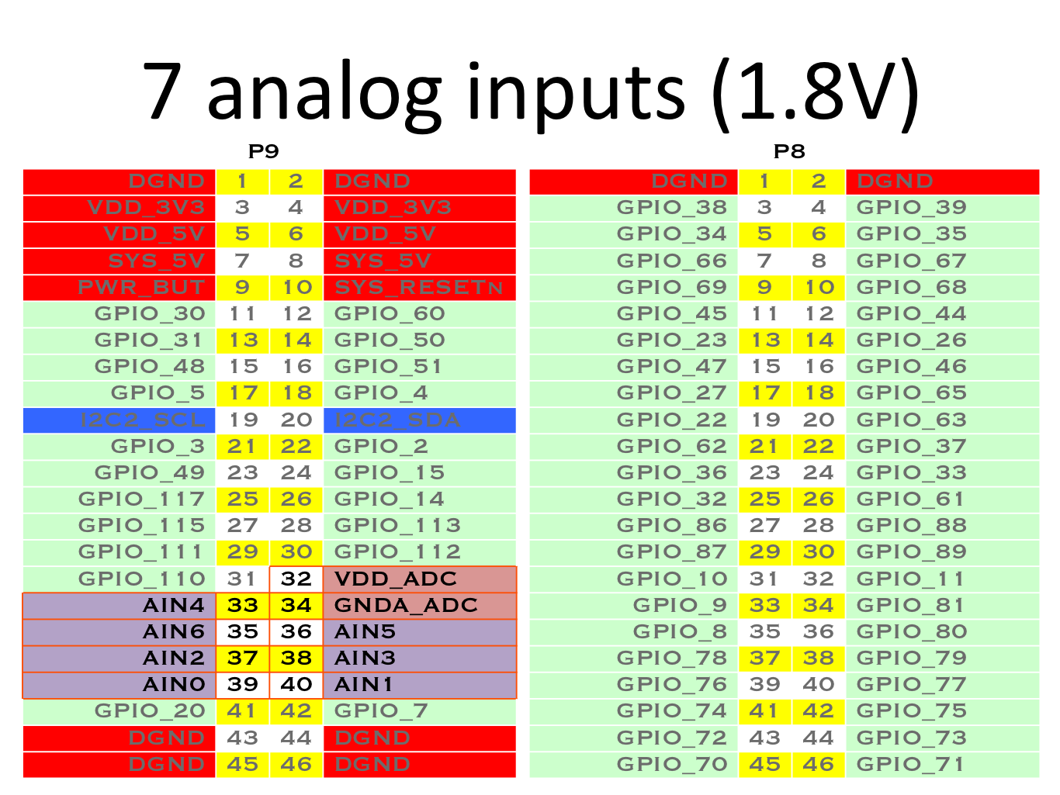

#### **UART**

**Note**

There is a dedicated header for getting to the UART0 pins and connecting a debug cable. Five additional serial ports are brought to the expansion headers, but one of them only has a single direction brought to the headers.

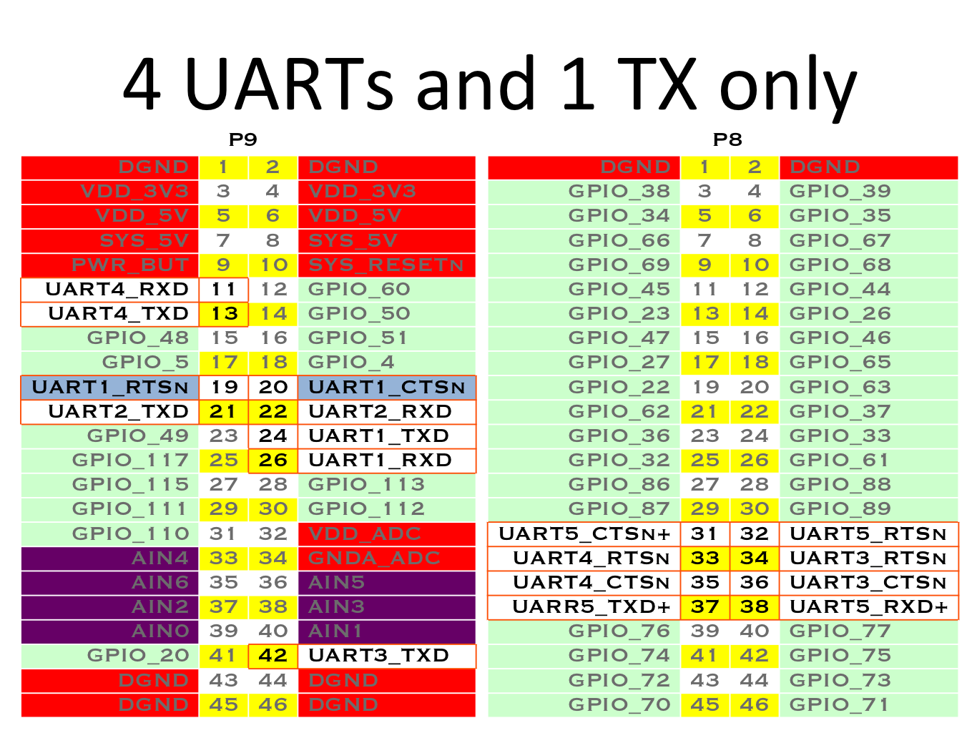

#### **I2C**

**Note**

The first I2C bus is utilized for reading EEPROMS on cape add-on boards and can’t be used for other digital I/O operations without interfering with that function, but you can still use it to add other I2C devices at available addresses. The second I2C bus is available for you to configure and use.

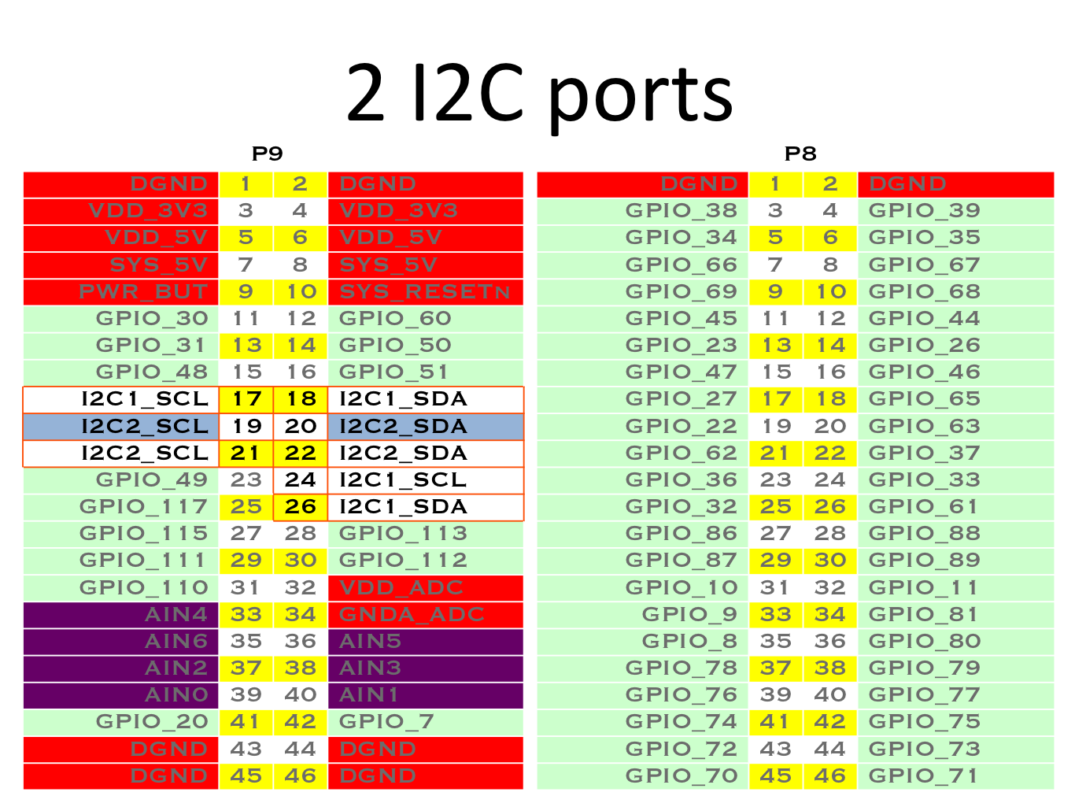

#### **SPI**

**Note**

For shifting out data fast, you might consider using one of the SPI ports.

